Experiment 1

Experiment Title
Demonstrate Inline, Internal, and External JavaScript; Use Console Methods; Create a Webpage Showing User Information and a Welcome Message.

Software/Tools Required
  - Visual Studio Code (VS Code)
  - Google Chrome / Mozilla Firefox / Microsoft Edge
  - HTML5
  - CSS3
  - JavaScript
  - Windows Operating System

Experiment Program Code
The experiment consists of the following files:
  - manthan.html
manthan_1234.html
<!DOCTYPE html>

<html lang="en">

<head>

<meta charset="UTF-8">

<meta name="viewport" content="width=device-width, initial-scale=1.0">

<title>Experiment No. 1</title>

<style>

body {

font-family: Arial, sans-serif; background-color: #f4f4f4; margin: 20px;
}

h2 {

text-align: center; color: #333;
}

.box {

width: 80%; margin: 20px auto; padding: 20px;
background-color: white; border: 1px solid #ccc; border-radius: 8px;
box-shadow: 0 0 10px rgba(0, 0, 0, 0.1);

}

h3 {

color: #007BFF; margin-bottom: 10px;
}

p {

font-size: 16px; color: #444;
}

button {

padding: 10px 20px; margin: 5px;
background-color: #007BFF; color: white;
border: none; border-radius: 5px; cursor: pointer; font-size: 15px;
}

button:hover {

background-color: #0056b3;

}

.output {

margin-top: 15px; padding: 10px;

border: 1px solid #999; border-radius: 5px; background-color: #f9f9f9; min-height: 40px;
}

#welcome { color: green;
font-weight: bold; font-size: 18px;
}

#info {

color: #222;

line-height: 1.6;

}

</style>

</head>

<body>

<h2>Experiment No. 1</h2>

<!-- Inline JavaScript -->

<div class="box">

<h3>Inline JavaScript</h3>

<p>

JavaScript code written directly inside HTML elements.

</p>

<button onclick="alert('Hello Manthan Gujar! Welcome to JavaScript Programming.')"> Click Me (Inline JS)
</button>

</div>

<!-- Internal JavaScript -->

<div class="box">

<h3>Internal JavaScript</h3>

<p>

JavaScript code written inside the &lt;script&gt; tag.

</p>

<button onclick="showUserInfo()"> Show User Information
</button>

<button onclick="consoleDemo()"> Console Methods Demo
</button>

<div class="output" id="info"></div>

</div>

<!-- External JavaScript -->

<div class="box">

<h3>External JavaScript</h3>

<p>

Click the button to display a welcome message.

</p>

<button onclick="showWelcome()"> Show Welcome Message
</button>

<div class="output">

<b>Welcome Message:</b>

<p id="welcome"></p>

</div>

</div>

<script>

// Internal JavaScript

function showUserInfo() { document.getElementById("info").innerHTML =
"<b>Name:</b> Manthan Gujar<br>" + "<b>PRN:</b> 24070521254<br>" +
"<b>Course:</b> Computer Science & Engineering";

}

function consoleDemo() { console.log("Console Log"); console.info("Console Info"); console.warn("Console Warning"); console.error("Console Error");

console.table([

{

Name: "Manthan Gujar", PRN: "24070521254",
Course: "Computer Science & Engineering"

}

]);

alert(

"Console Methods Executed! Check Browser Console (F12)."

);

}

// JavaScript previously written in script.js

function showWelcome() {

let name = "Manthan Gujar";

let currentHour = new Date().getHours(); let greeting = "";

if (currentHour < 12) {

greeting = "Good Morning";

} else if (currentHour < 17) { greeting = "Good Afternoon";
} else {

greeting = "Good Evening";

}

let message =

greeting + " " + name +

"! Welcome back to the JavaScript Programming.";

document.getElementById("welcome").innerHTML = message;

console.log(message);

console.info("Welcome message displayed.");

}

</script>

</body>

</html>

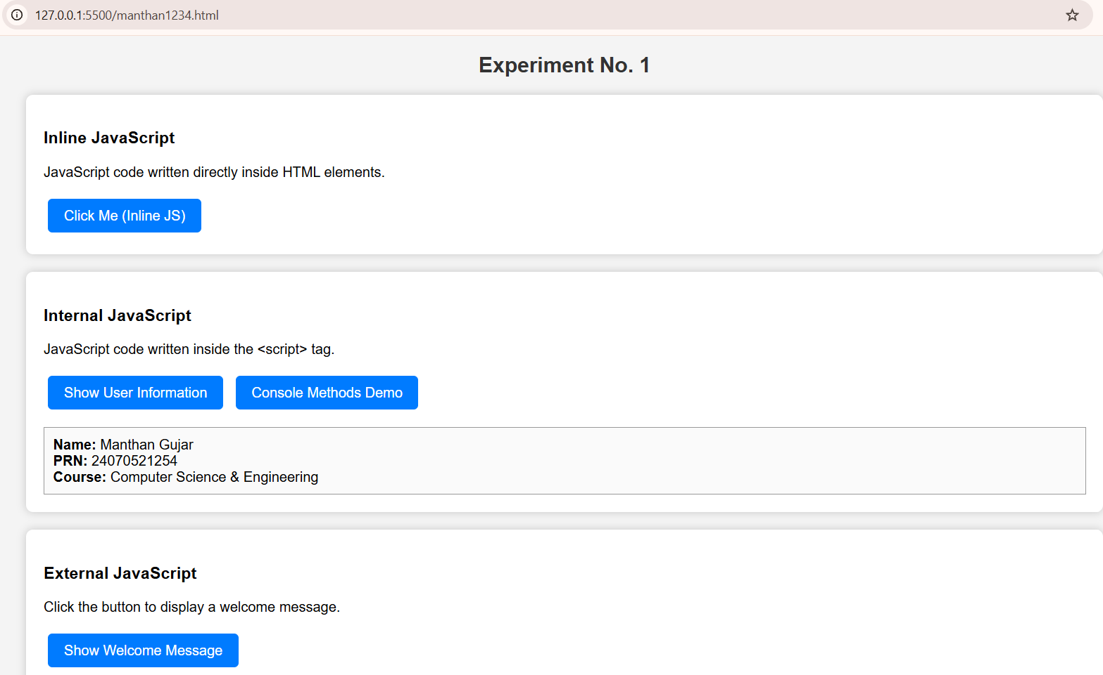
Output:

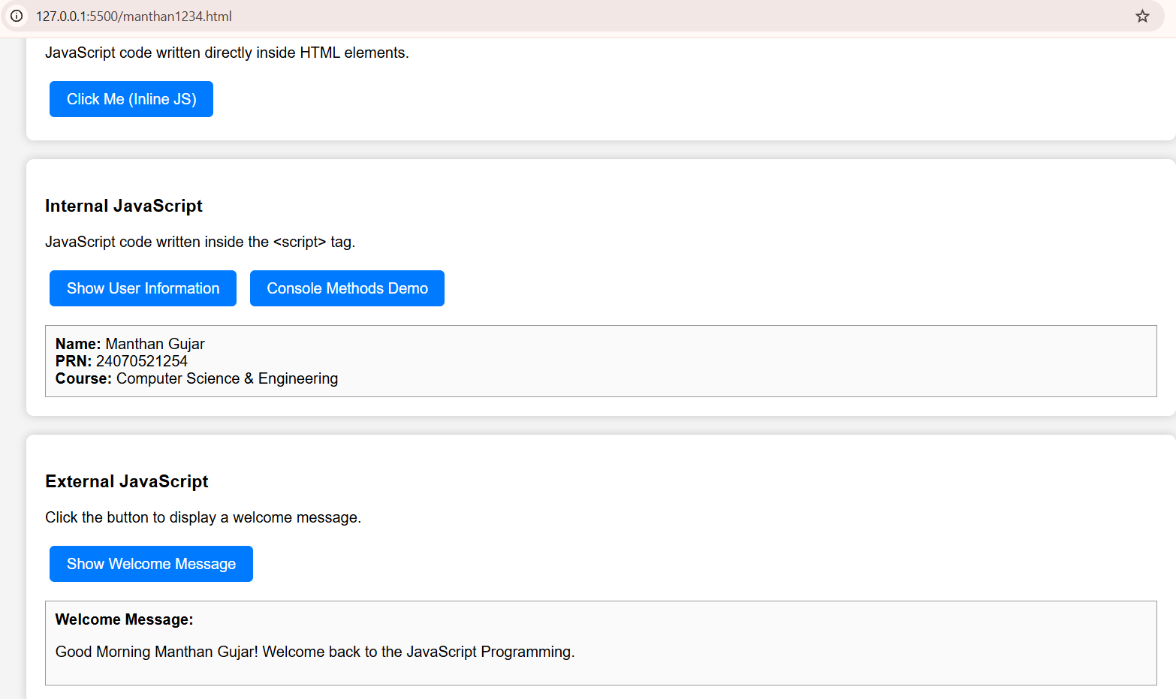

Case Study 1

Case Study Title
Create a Webpage for College Department and Link the Student Information Page with It and Write a JavaScript Program to Display "Welcome to SIT Nagpur" in an Alert Box.

Case Study Program Code
The case study consists of the following files:
  - manthan_1234.html – Displays the college department information and shows the alert message "Welcome to SIT Nagpur" using JavaScript.

manthan_1234.html

<!DOCTYPE html>
<html lang="en">

<head>
<meta charset="UTF-8">
<meta name="viewport" content="width=device-width, initial-scale=1.0">

<title>SIT Nagpur | Student Information</title>

<style>
* {
box-sizing: border-box;
}

body {
margin: 0;
min-height: 100vh; padding: 25px; display: flex;
justify-content: center; align-items: center;
font-family: Arial, sans-serif; color: #0f172a;
background: linear-gradient(135deg, #eaf1ff, #f8fafc);
}

.card {
width: 100%;
max-width: 480px; overflow: hidden; background-color: #ffffff; border-radius: 18px;
box-shadow: 0 18px 45px rgba(30, 64, 175, 0.18);
}

.header { padding: 30px;
text-align: center; color: white;
background: linear-gradient(135deg, #1e3a8a, #2563eb);
}

.logo {
width: 65px; height: 65px;
margin: 0 auto 14px; display: flex;
justify-content: center; align-items: center; border-radius: 50%; font-size: 28px;
background-color: rgba(255, 255, 255, 0.18);
}

.header h1 { margin: 0;
font-size: 27px;
}

.header p { margin: 8px 0 0; color: #dbeafe; font-size: 14px;
}

.content { padding: 30px;
}

label {
display: block; margin: 17px 0 7px; color: #334155; font-size: 14px; font-weight: bold;
}

label:first-child { margin-top: 0;
}

input {
width: 100%; padding: 13px;
border: 1px solid #cbd5e1; border-radius: 9px; outline: none;
font-size: 15px; transition: 0.3s;
}

input:focus {
border-color: #2563eb;
box-shadow: 0 0 0 4px rgba(37, 99, 235, 0.12);
}

button {
width: 100%; margin-top: 24px; padding: 14px; border: none; border-radius: 10px; color: white;
background: linear-gradient(135deg, #1d4ed8, #2563eb); font-size: 16px;
font-weight: bold; cursor: pointer;

transition: 0.3s;
}

button:hover {
transform: translateY(-2px);
box-shadow: 0 8px 18px rgba(37, 99, 235, 0.25);
}

#output { display: none;
margin-top: 24px; padding: 20px;
border: 1px solid #bfdbfe; border-radius: 12px; background-color: #eff6ff;
}

#output h2 { margin: 0 0 15px; color: #1d4ed8; font-size: 21px;
}

#output p { margin: 9px 0;
color: #475569; font-size: 14px; line-height: 1.5;
}

.success {
margin-top: 15px !important; padding-top: 14px;
color: #15803d !important; font-weight: bold;
border-top: 1px solid #bfdbfe;
}

.footer { padding: 15px;
text-align: center; color: #64748b;
background-color: #f8fafc; border-top: 1px solid #e2e8f0; font-size: 12px;
}

@media (max-width: 550px) { body {
padding: 15px;
}

.content { padding: 22px;
}

.header {
padding: 25px 20px;
}
}
</style>
</head>

<body>

<div class="card">

<div class="header">
<div class="logo">🎓</div>

<h1>SIT Nagpur</h1>

<p>Student Information Management System</p>
</div>

<div class="content">

<label for="name">Student Name</label>

<input
type="text" id="name"
placeholder="Enter your full name"
>

<label for="roll">Roll Number</label>

<input
type="text" id="roll"
placeholder="Enter your roll number"
>

<label for="department">Department</label>

<input
type="text" id="department"
placeholder="Example: Computer Science Engineering"
>

<button onclick="displayInformation()"> Submit Information
</button>

<div id="output"></div>

</div>

<div class="footer">
SIT Nagpur | Student Information Portal
</div>

</div>

<script>

console.log("SIT Nagpur Student Information Page Loaded"); function displayInformation() {
const name = document.getElementById("name").value.trim();

const roll = document.getElementById("roll").value.trim();

const department = document.getElementById("department").value.trim();

const output = document.getElementById("output");

if (
name === "" || roll === "" ||
department === ""
) {
alert("Please fill in all the required details."); console.error(
"Student information is incomplete."
);

return;
}
output.style.display = "block"; output.innerHTML = `
<h2>Welcome, ${name}!</h2>

<p>
<b>Roll Number:</b>
${roll}
</p>

<p>
<b>Department:</b>
${department}
</p>

<p class="success">
- Your information has been submitted successfully.
</p>
`;

console.log("Student Name:", name); console.log("Roll Number:", roll); console.log("Department:", department);

console.warn(
"Student information submitted successfully."
);
}

</script>

</body>

</html>

Output
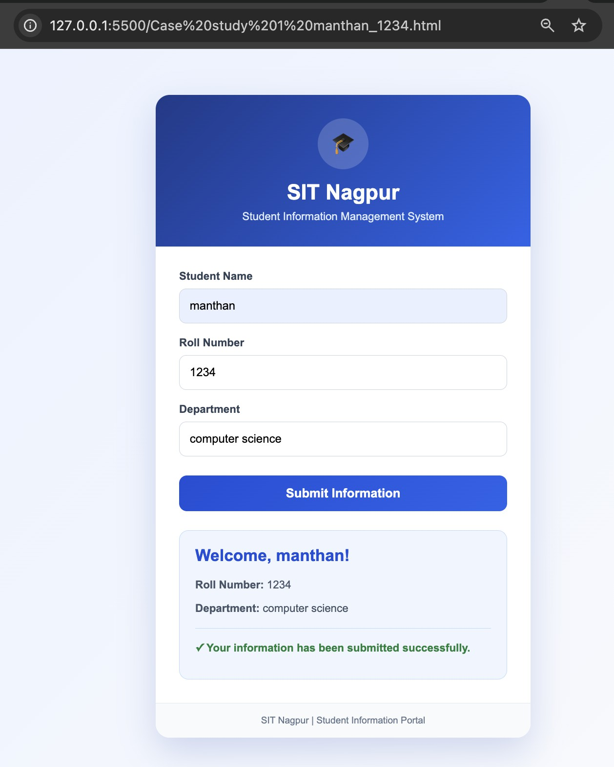

Result / Conclusion
The case study was successfully implemented by creating a college department webpage and linking it to a student information page. JavaScript was used to display the welcome message "Welcome to SIT Nagpur" in an alert box. The webpages were designed using HTML and CSS, while JavaScript provided the required interactivity. The objectives of the case study were successfully achieved.

Experiment 2

Experiment Title
Use var, let, const, and demonstrate basic features like template literals and destructuring; build a billing calculator with user input.

Software/Tools Required
  - Visual Studio Code (VS Code)
  - Google Chrome / Mozilla Firefox / Microsoft Edge
  - HTML5
  - CSS3
  - JavaScript
  - Windows Operating System

Experiment Program Code
The experiment consists of the following files:
  - manthan_1234.html manthan_1234.html
<!doctype html>
<html lang="en">
<head>
<meta charset="utf-8" />
<meta name="viewport" content="width=device-width,initial-scale=1" />
<title>Bill (Billing) Calculator</title>
<style>
body{font-family:Arial,sans-serif;background:#f5f7ff;margin:24px}
.card{max-width:520px;margin:auto;background:#fff;border:1px solid #e6e8ff;border-radius:14px;padding:16px} h2{margin:0 0 12px;font-size:18px}
label{display:block;margin:10px 0 6px;font-size:13px;color:#333} input,select{width:100%;padding:10px;border-radius:10px;border:1px solid #d9dcef}
.row{display:flex;gap:10px}
.row > div{flex:1}

button{margin-top:12px;width:100%;padding:10px;border:none;border-radius:10px;background:#3b6cff;color:#fff;font-weight:700;cursor:p ointer}
button:active{transform:translateY(1px)}
.out{margin-top:12px;padding:12px;border-radius:10px;background:#0f172a;color:#e5e7eb}
.small{color:#a9b6d3;font-size:12px;margin-bottom:6px}
</style>
</head>
<body>
<div class="card">
<h2>Bill (Billing) Calculator</h2>

<div class="row">
<div>
<label for="items">Items total</label>
<input id="items" type="number" step="any" placeholder="e.g., 120">
</div>
<div>
<label for="tax">Tax %</label>
<input id="tax" type="number" step="any" placeholder="e.g., 10">
</div>

</div>

<label for="tip">Tip %</label>
<input id="tip" type="number" step="any" placeholder="e.g., 5">

<label for="people">Split bill between (people)</label>
<select id="people">
<option value="1" selected>1 person</option>
<option value="2">2 people</option>
<option value="3">3 people</option>
<option value="4">4 people</option>
<option value="5">5 people</option>
<option value="6">6 people</option>
</select>

<button id="calcBtn" type="button">Calculate Bill</button>

<div class="out">
<div class="small" id="eq"></div>
<div style="font-size:22px;font-weight:800" id="result">—</div>
<div id="detail" style="margin-top:6px;color:#d1d5db;font-size:13px"></div>
</div>
</div>

<script>
// var / let / const demo
var appName = "billing-calculator"; let clickCount = 0;
const UI = {
invalid: "Enter valid numbers.",
divideZero: "Number of people cannot be 0.", total: "Total",
perPerson: "Per person"
};

const itemsEl = document.getElementById("items"); const taxEl = document.getElementById("tax"); const tipEl = document.getElementById("tip");
const peopleEl = document.getElementById("people");

const calcBtn = document.getElementById("calcBtn"); const eqEl = document.getElementById("eq");
const resultEl = document.getElementById("result"); const detailEl = document.getElementById("detail");

function readInputs() {
// Destructuring + basic parsing const data = {
items: Number(itemsEl.value), taxPct: Number(taxEl.value), tipPct: Number(tipEl.value), people: Number(peopleEl.value)
};
const { items, taxPct, tipPct, people } = data; // destructuring assignment return { items, taxPct, tipPct, people };
}

function calculate() { clickCount += 1;
const { items, taxPct, tipPct, people } = readInputs();

if ([items, taxPct, tipPct, people].some(n => Number.isNaN(n))) { resultEl.textContent = "—";
detailEl.textContent = UI.invalid; eqEl.textContent = "";

return;
}

if (people === 0) { resultEl.textContent = "—"; detailEl.textContent = UI.divideZero; eqEl.textContent = "";
return;
}

const taxAmt = items * (taxPct / 100); const tipAmt = items * (tipPct / 100); const total = items + taxAmt + tipAmt; const perPerson = total / people;

// Template literals
eqEl.textContent = `${items} + (${taxPct}% of ${items}) + (${tipPct}% of ${items})`; resultEl.textContent = `${UI.total}: ${total.toFixed(2)}`;
detailEl.textContent = `${UI.perPerson}: ${perPerson.toFixed(2)} (calc #${clickCount})`;

console.log(`${appName}: calc #${clickCount}`);
console.table([{ items, taxPct, tipPct, people, taxAmt, tipAmt, total, perPerson }]);
}

calcBtn.addEventListener("click", calculate);
</script>
</body>
</html>

Output:
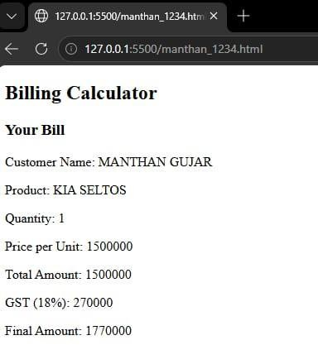

Case Study 2

Case Study Title
Develop the webpage for an online shopping website with using HTML CSS and HTML5 tags and calculate the bill.

Case Study Program Code
The case study consists of the following files:
  - manthan_1234.html – Displays the Premium Bill Calculator webpage containing a form to input customer and product details for generating an invoice.

manthan_1234.html

<!doctype html>

<html lang="en">

<head>

<meta charset="utf-8" />

<meta name="viewport" content="width=device-width, initial-scale=1" />

<title>Online Shopping - Bill Calculator</title>

<style>

:root{

--bg:#f4f6ff;

--card:#ffffff;

--text:#0f172a;

--muted:#64748b;

--border:#e5e7eb;

--primary:#2563eb;

--primary2:#1d4ed8;

--danger:#dc2626;

--success:#16a34a;

}

*{box-sizing:border-box} body{
margin:0;

font-family: ui-sans-serif, system-ui, -apple-system, Segoe UI, Roboto, Arial; background: linear-gradient(180deg, #eef2ff, var(--bg));
color:var(--text);

}

header{ padding:22px 16px; text-align:center;
}

header h1{margin:0 0 6px; font-size:22px} header p{margin:0; color:var(--muted)}
main{max-width:1100px; margin:0 auto; padding:16px}

.grid{display:grid; grid-template-columns: 1.2fr .8fr; gap:16px} @media (max-width: 920px){ .grid{grid-template-columns:1fr} }

section.card{ background:var(--card);
border:1px solid var(--border); border-radius:14px; padding:16px;
}

h2{margin:0 0 12px; font-size:16px}

label{display:block; margin:10px 0 6px; font-size:13px; color:var(--muted)} input, select{
width:100%; padding:10px 12px;
border:1px solid var(--border); border-radius:10px; outline:none;
font-size:14px; background:#fff;
}

input:focus, select:focus{

border-color: rgba(37,99,235,.6);

box-shadow: 0 0 0 3px rgba(37,99,235,.15);

}

.row{display:grid; grid-template-columns:1fr 1fr; gap:12px} @media (max-width: 520px){ .row{grid-template-columns:1fr} }

.btns{display:flex; gap:10px; margin-top:14px}

button{ border:none;
border-radius:10px; padding:11px 14px; cursor:pointer;
font-weight:700; font-size:14px; width:100%;
background:var(--primary); color:#fff;
}

button:hover{background:var(--primary2)}

.btn-secondary{background:#475569}

.btn-secondary:hover{background:#334155}

table{width:100%; border-collapse:collapse; margin-top:10px}

th, td{padding:10px; border-bottom:1px solid var(--border); text-align:left; font-size:14px} th{color:var(--muted); font-weight:600}
.summary{ display:grid; gap:10px; margin-top:10px; padding:12px;
background:#0b1220; border-radius:14px; color:#e5e7eb;
}

.summary .line{

display:flex; justify-content:space-between; gap:10px; font-size:14px;
}

.summary .line strong{font-size:15px}

.total{ color:#34d399; font-size:18px; font-weight:900;
}

.err{

margin-top:8px; color:var(--danger); font-size:13px;
min-height:18px;

}

footer{

text-align:center; padding:18px 16px; color:var(--muted); font-size:13px;
}

</style>

</head>

<body>

<header>

<h1>ShopNow Online Shopping</h1>

<p>Enter customer & product details to calculate your bill.</p>

</header>

<main>

<div class="grid">

<!-- Customer + Product -->

<section class="card">

<h2>Customer & Order Details</h2>

<!-- HTML5 tag usage: form, fieldset, legend -->

<form id="orderForm">

<fieldset style="border:1px solid var(--border); border-radius:12px; padding:12px;">

<legend style="padding:0 8px; color:var(--muted); font-weight:700;">Customer</legend>

<div class="row">

<div>

<label for="customerName">Customer Name</label>

<input id="customerName" type="text" placeholder="e.g., Ali" required />

</div>

<div>

<label for="mobile">Mobile Number</label>

<input id="mobile" type="tel" placeholder="e.g., 9876543210" required maxlength="15" />

</div>

</div>

</fieldset>

<fieldset style="border:1px solid var(--border); border-radius:12px; padding:12px; margin-top:14px;">

<legend style="padding:0 8px; color:var(--muted); font-weight:700;">Product & Billing</legend>

<div class="row">

<div>

<label for="productName">Product Name</label>

<input id="productName" type="text" placeholder="e.g., Headphones" required />

</div>

<div>

<label for="quantity">Quantity</label>

<input id="quantity" type="number" min="1" step="1" value="1" required />

</div>

</div>

<div class="row">

<div>

<label for="price">Price per item</label>

<input id="price" type="number" min="0" step="0.01" placeholder="e.g., 499.99" required />

</div>

<div>

<label for="discount">Discount (Amount or %)</label>

<!-- using select to interpret discount -->

<div style="display:grid; grid-template-columns: 1fr 140px; gap:10px;">

<input id="discount" type="number" min="0" step="0.01" placeholder="e.g., 50 or 10" required />

<select id="discountType">

<option value="amount" selected>Amount</option>

<option value="percent">Percent</option>

</select>

</div>

</div>

</div>

<div class="row">

<div>

<label for="gst">GST %</label>

<input id="gst" type="number" min="0" step="0.01" placeholder="e.g., 18" required value="18" />

</div>

<div>

<label for="discountNotes">Tip (Optional)</label>

<input id="notes" type="text" placeholder="e.g., thank you!" />

</div>

</div>

<div class="btns">

<button type="button" id="calcBtn">Calculate Bill</button>

<button type="button" class="btn-secondary" id="clearBtn">Clear</button>

</div>

<div id="error" class="err" role="alert"></div>

</fieldset>

</form>

</section>

<!-- Bill -->

<aside class="card">

<h2>Bill Summary</h2>

<table>

<thead>

<tr>

<th>Item</th>

<th>Value</th>

</tr>

</thead>

<tbody>

<tr><td>Customer</td><td id="sumCustomer">—</td></tr>

<tr><td>Mobile</td><td id="sumMobile">—</td></tr>

<tr><td>Product</td><td id="sumProduct">—</td></tr>

<tr><td>Quantity</td><td id="sumQty">—</td></tr>

<tr><td>Subtotal</td><td id="sumSubtotal">—</td></tr>

<tr><td>Discount</td><td id="sumDiscount">—</td></tr>

<tr><td>GST</td><td id="sumGst">—</td></tr>

</tbody>

</table>

<div class="summary" aria-live="polite">

<div class="line"><span>Total</span><strong class="total" id="sumTotal">—</strong></div>

<div class="line" style="color:#cbd5e1;">

<span>Final amount includes GST</span>

<span id="sumGstRate"></span>

</div>

</div>

<p class="err" id="calcErr" style="min-height:0;"></p>

</aside>

</div>

</main>

<script>

// Elements

const customerNameEl = document.getElementById("customerName"); const mobileEl = document.getElementById("mobile");
const productNameEl = document.getElementById("productName"); const quantityEl = document.getElementById("quantity");
const priceEl = document.getElementById("price");

const discountEl = document.getElementById("discount");

const discountTypeEl = document.getElementById("discountType"); const gstEl = document.getElementById("gst");

const calcBtn = document.getElementById("calcBtn"); const clearBtn = document.getElementById("clearBtn"); const errorEl = document.getElementById("error"); const calcErrEl = document.getElementById("calcErr");

// Summary elements

const sumCustomer = document.getElementById("sumCustomer"); const sumMobile = document.getElementById("sumMobile"); const sumProduct = document.getElementById("sumProduct"); const sumQty = document.getElementById("sumQty");
const sumSubtotal = document.getElementById("sumSubtotal"); const sumDiscount = document.getElementById("sumDiscount"); const sumGst = document.getElementById("sumGst");
const sumTotal = document.getElementById("sumTotal");

const sumGstRate = document.getElementById("sumGstRate");

// Format helper

const money = (n) => { const num = Number(n);
if (!Number.isFinite(num)) return "—"; return num.toFixed(2);
};

function validate() { errorEl.textContent = ""; calcErrEl.textContent = "";

const customerName = customerNameEl.value.trim(); const mobile = mobileEl.value.trim();
const productName = productNameEl.value.trim();

const quantity = Number(quantityEl.value); const price = Number(priceEl.value);
const discount = Number(discountEl.value); const gstPct = Number(gstEl.value);

// Control validation (if/else)

if (!customerName) return "Customer name is required."; if (!productName) return "Product name is required.";

// simple mobile validation: digits length 7-15

if (!/^\d{7,15}$/.test(mobile)) return "Enter a valid mobile number (7-15 digits).";

if (!Number.isFinite(quantity) || quantity < 1) return "Quantity must be at least 1."; if (!Number.isFinite(price) || price < 0) return "Price per item must be 0 or more."; if (!Number.isFinite(discount) || discount < 0) return "Discount must be 0 or more."; if (!Number.isFinite(gstPct) || gstPct < 0) return "GST% must be 0 or more.";

return null;

}

// Calculate using try/catch function calculateBill() { try {
const err = validate(); if (err) {
errorEl.textContent = err; return;
}

const customerName = customerNameEl.value.trim(); const mobile = mobileEl.value.trim();
const productName = productNameEl.value.trim();

const quantity = Number(quantityEl.value); const price = Number(priceEl.value);
const discount = Number(discountEl.value); const gstPct = Number(gstEl.value);

const discountType = discountTypeEl.value;

// Subtotal

const subtotal = quantity * price;

// Discount amount

let discountAmount = 0;

if (discountType === "percent") { discountAmount = subtotal * (discount / 100);

} else {

discountAmount = discount; // amount

}

// Prevent discount > subtotal

if (discountAmount > subtotal) discountAmount = subtotal;

const afterDiscount = subtotal - discountAmount;

// GST amount

const gstAmount = afterDiscount * (gstPct / 100);

// Total

const total = afterDiscount + gstAmount;

// Update UI

sumCustomer.textContent = customerName; sumMobile.textContent = mobile; sumProduct.textContent = productName; sumQty.textContent = quantity;

sumSubtotal.textContent = money(subtotal); sumDiscount.textContent = money(discountAmount); sumGst.textContent = money(gstAmount);

sumGstRate.textContent = `GST Rate: ${gstPct}%`;

sumTotal.textContent = money(total);

// small console output

console.log("Bill calculated:", { subtotal, discountAmount, gstAmount, total });

} catch (e) {

errorEl.textContent = "Something went wrong. Please check your input."; console.error(e);
}

}

function clearAll() { errorEl.textContent = ""; calcErrEl.textContent = "";

customerNameEl.value = ""; mobileEl.value = ""; productNameEl.value = ""; quantityEl.value = 1; priceEl.value = ""; discountEl.value = ""; discountTypeEl.value = "amount"; gstEl.value = 18;

sumCustomer.textContent = "—"; sumMobile.textContent = "—"; sumProduct.textContent = "—"; sumQty.textContent = "—"; sumSubtotal.textContent = "—"; sumDiscount.textContent = "—"; sumGst.textContent = "—"; sumGstRate.textContent = ""; sumTotal.textContent = "—";
}

calcBtn.addEventListener("click", calculateBill); clearBtn.addEventListener("click", clearAll);
</script>

</body>

</html>

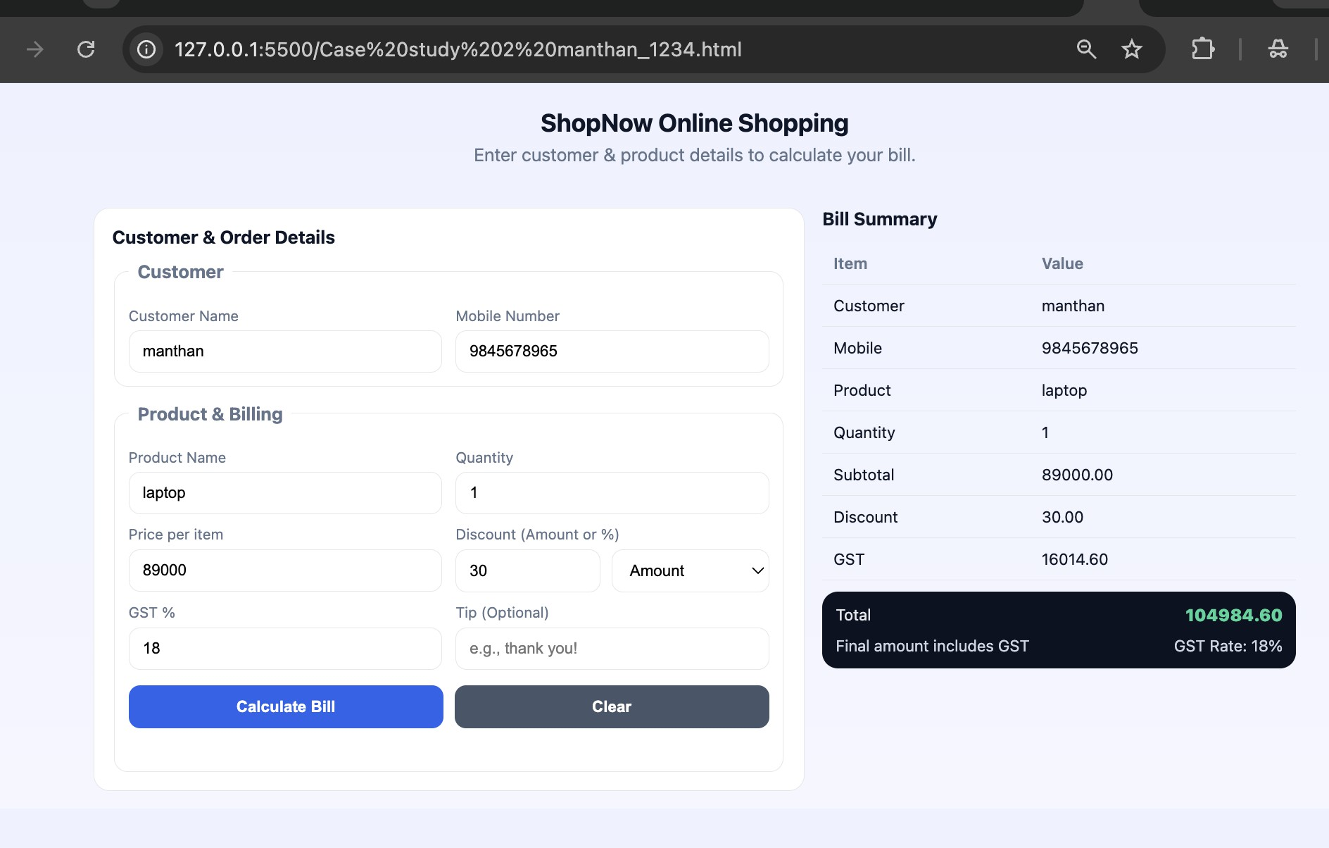
Output:

Result/Conclusion:
Hence, we have successfully developed the Premium Bill Calculator webpage. Through this case study, we practically learned how to declare variables using var, let, and const, utilize various primitive data types (such as strings, numbers, and booleans), and perform type coercion and explicit type conversions in JavaScript to compute the final bill amount and dynamically display the generated invoice.

Experiment 3

Experiment Title
Implement control structures and form validation; create a grading system based on user-entered marks.

Software/Tools Required
  - Visual Studio Code (VS Code)
  - Google Chrome / Mozilla Firefox / Microsoft Edge
  - HTML5
  - CSS3
  - JavaScript
  - Windows Operating System

Experiment Program Code
The experiment consists of the following files:
  - manthan_1234.html

manthan_1234.html
<!DOCTYPE html>
<html lang="en">

<head>
<meta charset="UTF-8">
<meta name="viewport" content="width=device-width, initial-scale=1.0">
<title>Student Grading System</title>

<style>
* {
box-sizing: border-box;
}

body {
margin: 0;
min-height: 100vh;
font-family: Arial, sans-serif;
background: linear-gradient(135deg, #eaf1ff, #f8fafc); display: flex;
justify-content: center; align-items: center;

padding: 25px; color: #1e293b;
}

.card {
width: 650px; background-color: white; border-radius: 20px; overflow: hidden;
box-shadow: 0 18px 45px rgba(30, 64, 175, 0.18);
}

.header { padding: 30px;
text-align: center; color: white;
background: linear-gradient(135deg, #1e3a8a, #2563eb);
}

.icon {
width: 62px; height: 62px;
margin: 0 auto 15px; display: flex;
justify-content: center; align-items: center; border-radius: 50%;
background-color: rgba(255, 255, 255, 0.18); font-size: 28px;
}

.header h1 { margin: 0;
font-size: 27px;
}

.header p { margin: 8px 0 0; color: #dbeafe; font-size: 14px;
}

.content { padding: 30px;
}

.student-row { display: flex; gap: 15px;
margin-bottom: 20px;
}

.student-group { width: 50%;
}

label {
display: block; margin-bottom: 8px; color: #334155;
font-size: 14px; font-weight: bold;
}

input {
width: 100%; padding: 13px;
border: 1px solid #cbd5e1; border-radius: 9px; outline: none;
font-size: 15px;
}

input:focus {
border-color: #2563eb;
box-shadow: 0 0 0 4px rgba(37, 99, 235, 0.12);
}

.subject-title { margin-top: 15px;
margin-bottom: 15px; color: #1e3a8a;

font-size: 18px;
}

.subjects { display: grid;
grid-template-columns: 1fr 1fr; gap: 15px;
}

.subject-box { padding: 15px;
border: 1px solid #e2e8f0; border-radius: 12px; background-color: #f8fafc;
}

.subject-box label { color: #334155;
}

.error {
min-height: 18px; margin-top: 7px; color: #dc2626; font-size: 12px;
}

button {
width: 100%; padding: 14px; margin-top: 25px; border: none; border-radius: 10px; color: white;
background: linear-gradient(135deg, #1d4ed8, #2563eb); font-size: 16px;
font-weight: bold; cursor: pointer; transition: 0.3s;
}

button:hover {
transform: translateY(-2px);
box-shadow: 0 8px 18px rgba(37, 99, 235, 0.25);
}

.result-box { display: none; margin-top: 25px; padding: 22px; text-align: center;
border-radius: 12px; background-color: #eff6ff; border: 1px solid #bfdbfe;
}

.result-label { margin: 0; color: #64748b; font-size: 13px;
}

#result {
margin: 8px 0; color: #1d4ed8; font-size: 28px; font-weight: bold;
}

#details { margin: 0;
color: #475569; font-size: 14px; line-height: 1.8;
}

.subject-result { margin-top: 20px; padding: 15px; text-align: left;
border-radius: 10px; background: white;

border: 1px solid #dbeafe;
}

.subject-result h3 { margin: 0 0 12px; color: #1e3a8a;
}

.subject-result p { margin: 7px 0;
color: #475569;
}

.footer { padding: 15px;
text-align: center; color: #64748b; background: #f8fafc;
border-top: 1px solid #e2e8f0; font-size: 12px;
}

@media (max-width: 600px) {
.card {
width: 100%;
}

.student-row {
flex-direction: column;
}

.student-group { width: 100%;
}

.subjects {
grid-template-columns: 1fr;
}
}
</style>
</head>

<body>

<div class="card">

<div class="header">
<div class="icon">🎓</div>

<h1>Student Grading System</h1>

<p>Enter subject-wise marks to calculate your result</p>
</div>

<div class="content">

<div class="student-row">

<div class="student-group">
<label>Student Name</label>

<input
type="text" id="studentName"
placeholder="Enter student name"
>
</div>

<div class="student-group">
<label>Roll Number</label>

<input
type="text" id="rollNumber"
placeholder="Enter roll number"
>
</div>

</div>

<h2 class="subject-title">Enter Subject-wise Marks</h2>

<div class="subjects">

<div class="subject-box">
<label>Mathematics</label>

<input
type="number" id="math"
placeholder="Marks out of 100" min="0"
max="100"
>
</div>

<div class="subject-box">
<label>Physics</label>

<input
type="number" id="physics"
placeholder="Marks out of 100" min="0"
max="100"
>
</div>

<div class="subject-box">
<label>Chemistry</label>

<input
type="number" id="chemistry"
placeholder="Marks out of 100" min="0"
max="100"
>
</div>

<div class="subject-box">
<label>Computer Science</label>

<input
type="number" id="computer"
placeholder="Marks out of 100" min="0"
max="100"
>
</div>

<div class="subject-box">
<label>English</label>

<input
type="number" id="english"
placeholder="Marks out of 100" min="0"
max="100"
>
</div>

</div>

<div class="error" id="errorMessage"></div>

<button onclick="calculateGrade()"> Calculate Result
</button>

<div class="result-box" id="resultBox">

<p class="result-label">STUDENT RESULT</p>

<h2 id="result">—</h2>

<p id="details"></p>

<div
class="subject-result" id="subjectResult"
></div>

</div>

</div>

<div class="footer">
Student Academic Performance Calculator
</div>

</div>

<script>

function calculateGrade() {

const studentName = document.getElementById("studentName").value;

const rollNumber = document.getElementById("rollNumber").value;

const math = Number(document.getElementById("math").value);

const physics = Number(document.getElementById("physics").value);

const chemistry = Number(document.getElementById("chemistry").value);

const computer = Number(document.getElementById("computer").value);

const english = Number(document.getElementById("english").value);

const errorMessage = document.getElementById("errorMessage");

const resultBox = document.getElementById("resultBox");

errorMessage.textContent = "";

resultBox.style.display = "none";

const marks = [ math, physics, chemistry, computer, english
];

if (studentName === "") {

errorMessage.textContent = "Please enter student name.";

return;
}

if ( marks.some(
mark => Number.isNaN(mark)
)
) {

errorMessage.textContent =
"Please enter marks for all subjects.";

return;
}

if ( marks.some(
mark => mark < 0 || mark > 100
)
) {

errorMessage.textContent =
"Marks must be between 0 and 100.";

return;
}

const total = math + physics + chemistry + computer + english;

const percentage = total / 5;

let grade; let remark;

if (percentage >= 90) {

grade = "A";

remark =
"Excellent Performance";

} else if (percentage >= 80) {

grade = "B";

remark =
"Very Good Performance";

} else if (percentage >= 70) {

grade = "C";

remark =
"Good Performance";

} else if (percentage >= 60) {

grade = "D";

remark = "Pass";

} else {

grade = "F";

remark =
"Needs Improvement";
}

document
.getElementById("result")
.textContent = "Grade " + grade;

document
.getElementById("details")
.innerHTML =

"<b>Student:</b> " + studentName +

"<br>" +

"<b>Roll Number:</b> " + rollNumber +

"<br><br>" +

"<b>" +
remark + "</b>" +

"<br>" +

"Total Marks: " + total +
" / 500" +

"<br>" +

"Percentage: " + percentage.toFixed(2) + "%";

document
.getElementById("subjectResult")
.innerHTML =

"<h3>Subject-wise Result</h3>" +

"<p>Mathematics: " + math +
" / 100</p>" +

"<p>Physics: " + physics +
" / 100</p>" +

"<p>Chemistry: " + chemistry +
" / 100</p>" +

"<p>Computer Science: " + computer +
" / 100</p>" +

"<p>English: " + english +
" / 100</p>";

resultBox.style.display = "block";
}

</script>

</body>

</html>

Output:
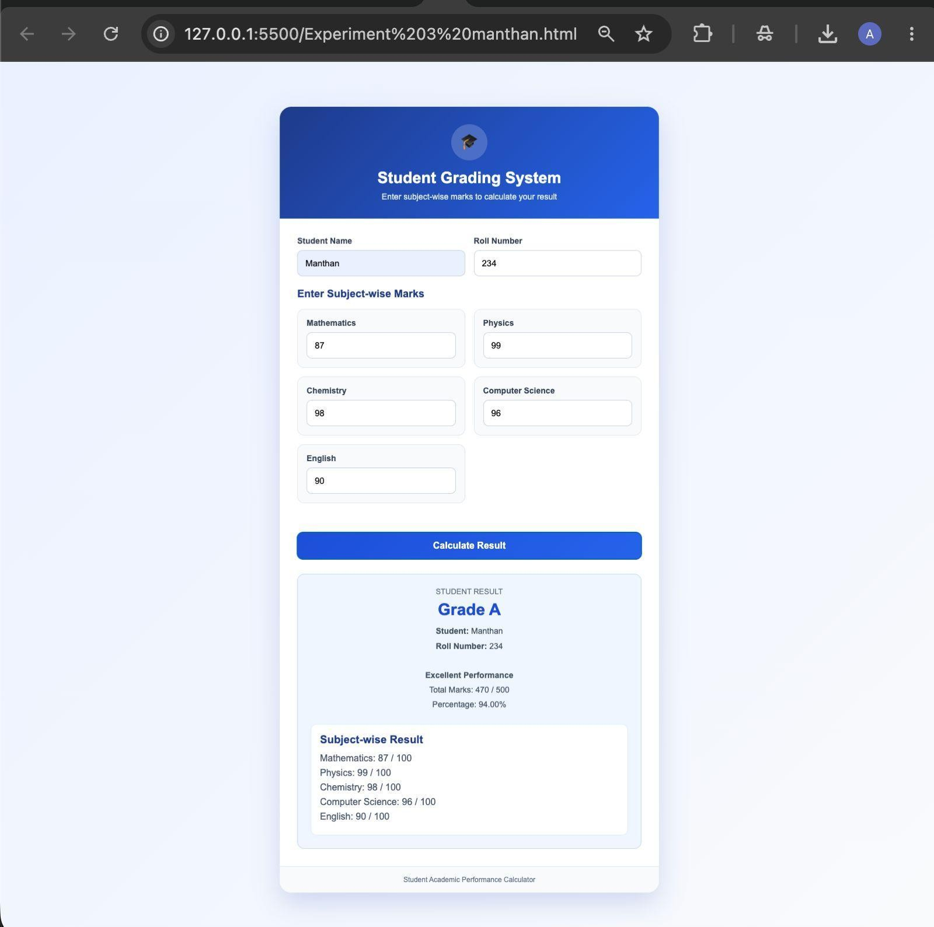

Case Study 3

Case Study Title
Write a Javascript program that accepts students marks and displays the scholarship category.

Case Study Program Code
The case study consists of the following files:

  - manthan_1234.html – Displays the Scholarship Eligibility Checker webpage, containing an input form for students to enter their marks and a section outlining the various scholarship criteria.

manthan_1234.html
<!DOCTYPE html>

<html lang="en">

<head>

<meta charset="UTF-8">

<meta name="viewport" content="width=device-width, initial-scale=1.0">

<title>Scholarship Eligibility Calculator</title>

<style>

* {

box-sizing: border-box;

}

body {

margin: 0;

min-height: 100vh;

font-family: Arial, sans-serif;

background: linear-gradient(135deg, #eaf2ff, #f8fbff); display: flex;
justify-content: center; align-items: center; color: #1e293b;
}

.card {

width: 450px; background-color: white; border-radius: 18px; overflow: hidden;
box-shadow: 0 15px 40px rgba(30, 64, 175, 0.18);

}

.header {

background: #1e40af; color: white;
text-align: center; padding: 28px;
}

.header h1 { margin: 0;
font-size: 25px;

}

.header p { margin: 8px 0 0; font-size: 14px; color: #dbeafe;
}

.content { padding: 30px;
}

label {

display: block; margin-bottom: 8px; font-size: 15px;
font-weight: bold; color: #334155;
}

input {

width: 100%; padding: 14px;
border: 1px solid #cbd5e1; border-radius: 9px;
font-size: 16px; outline: none;
}

input:focus {

border-color: #2563eb;

box-shadow: 0 0 0 3px rgba(37, 99, 235, 0.12);

}

button {

width: 100%; margin-top: 20px; padding: 14px;
background-color: #2563eb; color: white;
border: none; border-radius: 9px; font-size: 16px; font-weight: bold; cursor: pointer;
}

button:hover {

background-color: #1d4ed8;

}

#result { display: none;
margin-top: 22px; padding: 18px; border-radius: 10px;

text-align: center; background-color: #eff6ff; border: 1px solid #bfdbfe;
}

#result h2 { margin: 0 0 8px; color: #1d4ed8; font-size: 20px;
}

#result p { margin: 0;
color: #475569;

line-height: 1.5;

}

.criteria {

margin-top: 25px; padding: 18px; background-color: #f8fafc; border-radius: 10px; border: 1px solid #e2e8f0;
}

.criteria h3 { margin: 0 0 12px; color: #1e293b; font-size: 16px;
}

.criteria p { margin: 9px 0; font-size: 14px; color: #475569;
}

.footer {

text-align: center; padding: 15px; background-color: #f8fafc; color: #64748b;
font-size: 12px;

}

</style>

</head>

<body>

<div class="card">

<div class="header">

<h1>Scholarship Eligibility</h1>

<p>Check your scholarship category based on marks</p>

</div>

<div class="content">

<label for="marks">Enter Your Marks</label>

<input

type="number" id="marks" min="0" max="100"
placeholder="Enter marks from 0 to 100"

>

<button onclick="getCategory()">Check Eligibility</button>

<div id="result"></div>

<div class="criteria">

<h3>Scholarship Criteria</h3>

<p><b>Gold Scholarship:</b> 90 – 100 Marks</p>

<p><b>Silver Scholarship:</b> 75 – 89 Marks</p>

<p><b>Bronze Scholarship:</b> 60 – 74 Marks</p>

<p><b>No Scholarship:</b> Below 60 Marks</p>

</div>

</div>

<div class="footer">

Scholarship Eligibility Calculator

</div>

</div>

<script>

function getCategory() {

const marksInput = document.getElementById("marks"); const marks = Number(marksInput.value);
const result = document.getElementById("result");

result.style.display = "block";

if (marksInput.value === "") { result.innerHTML =
"<h2>Input Required</h2>" + "<p>Please enter your marks.</p>";
return;

}

if (marks < 0 || marks > 100) { result.innerHTML =
"<h2>Invalid Marks</h2>" +

"<p>Please enter marks between 0 and 100.</p>"; return;
}

let category; let message;

if (marks >= 90) {

category = "Gold Scholarship"; message =

"Congratulations! You are eligible for the Gold Scholarship.";

} else if (marks >= 75) {

category = "Silver Scholarship"; message =
"Congratulations! You are eligible for the Silver Scholarship.";

} else if (marks >= 60) {

category = "Bronze Scholarship"; message =
"Congratulations! You are eligible for the Bronze Scholarship.";

} else {

category = "No Scholarship"; message =
"You are currently not eligible for a scholarship.";

}

result.innerHTML =

"<h2>" + category + "</h2>" + "<p>" + message + "</p>";

console.log("Student Marks:", marks); console.log("Scholarship Category:", category);
}

</script>

</body>

</html>

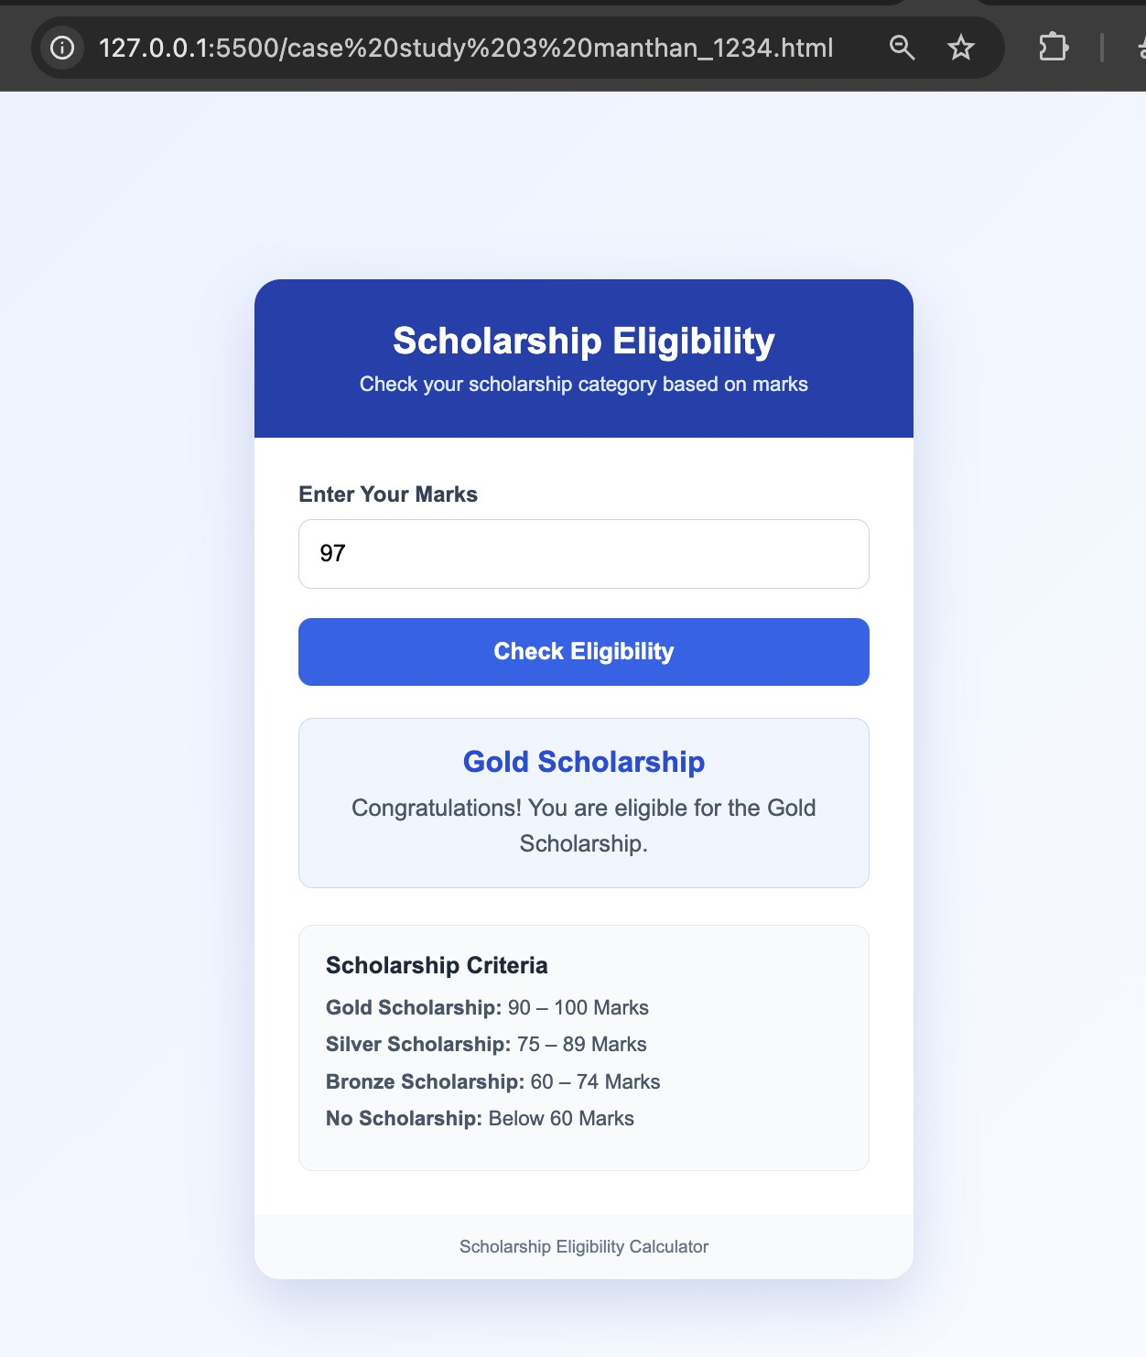
Output:

Result / Conclusion:
Hence, we have successfully developed the Scholarship Eligibility Checker webpage. Through this case study, we practically learned how to implement control structures, specifically if-else conditional statements in JavaScript, to evaluate user input, make logical decisions, and dynamically update the webpage's UI to display the appropriate scholarship category based on the provided marks.

Experiment 4

Experiment Title
Use function types, scope, and closures; apply try-catch; build a palindrome checker.

Software/Tools Required
  - Visual Studio Code (VS Code)
  - Google Chrome / Mozilla Firefox / Microsoft Edge
  - HTML5
  - CSS3
  - JavaScript
  - Windows Operating System

Experiment Program Code
The experiment consists of the following files:
  - manthan_1234.html
manthan_1234.html
<!doctype html>

<html lang="en">

<head>

<meta charset="utf-8" />

<meta name="viewport" content="width=device-width,initial-scale=1" />

<title>Palindrome Checker (try/catch + closures)</title>

<style>

body{font-family:Arial,sans-serif;background:#f5f7ff;margin:24px}

.card{max-width:520px;margin:auto;background:#fff;border:1px solid #e6e8ff;border-radius:14px;padding:16px} h2{margin:0 0 12px;font-size:18px}
label{display:block;margin:10px 0 6px;font-size:13px;color:#333} input{width:100%;padding:10px;border-radius:10px;border:1px solid #d9dcef}

button{margin-top:12px;width:100%;padding:10px;border:none;border-radius:10px;background:#3b6cff;color:#fff;font-weight:700;cursor:p ointer}
button:active{transform:translateY(1px)}

.out{margin-top:12px;padding:12px;border-radius:10px;background:#0f172a;color:#e5e7eb}

.small{color:#a9b6d3;font-size:12px;margin-top:8px}

</style>

</head>

<body>

<div class="card">

<h2>Palindrome Checker</h2>

<label for="text">Enter text</label>

<input id="text" type="text" placeholder="e.g., racecar" />

<button id="checkBtn" type="button">Check Palindrome</button>

<div class="out">

<div id="result" style="font-size:20px;font-weight:800;">—</div>

<div id="meta" class="small"></div>

</div>

</div>

<script>

// function types: declaration + expression + arrow (used below) function normalize(str) {
// remove spaces + punctuation, lowercase

return str.toLowerCase().replace(/[^a-z0-9]/g, "");

}

const isPalindrome = function (s) { // function expression let i = 0;
let j = s.length - 1; while (i < j) {
if (s[i] !== s[j]) return false; i++;
j--;

}

return true;

};

const formatAnswer = (ok, original, cleaned) => { // arrow function

// template literal
return `${ok ? "Palindrome ✅" : "Not a palindrome ❌"}<br/>Input: "${original}"<br/>Normalized: "${cleaned}"`;
};

// closures + scope:

// create a checker factory that remembers how many checks were done function createPalindromeChecker() {
let count = 0; // captured by the returned function (closure)

return function check() { // inner function closes over "count" count += 1;

const inputEl = document.getElementById("text"); const original = inputEl.value;

try {

// try/catch: force an error if input is empty after trimming if (!original || original.trim().length === 0) {
throw new Error("Empty input");

}

const cleaned = normalize(original); const ok = isPalindrome(cleaned);

const resultEl = document.getElementById("result"); const metaEl = document.getElementById("meta");

resultEl.innerHTML = formatAnswer(ok, original, cleaned); metaEl.textContent = `Checks done (closure count): ${count}`;
} catch (err) { document.getElementById("result").textContent = "—";
document.getElementById("meta").textContent = `Error: ${err.message}. Please enter some text.`;

}

};

}

// Use the closure

const check = createPalindromeChecker(); document.getElementById("checkBtn").addEventListener("click", check);
</script>

</body>

</html>

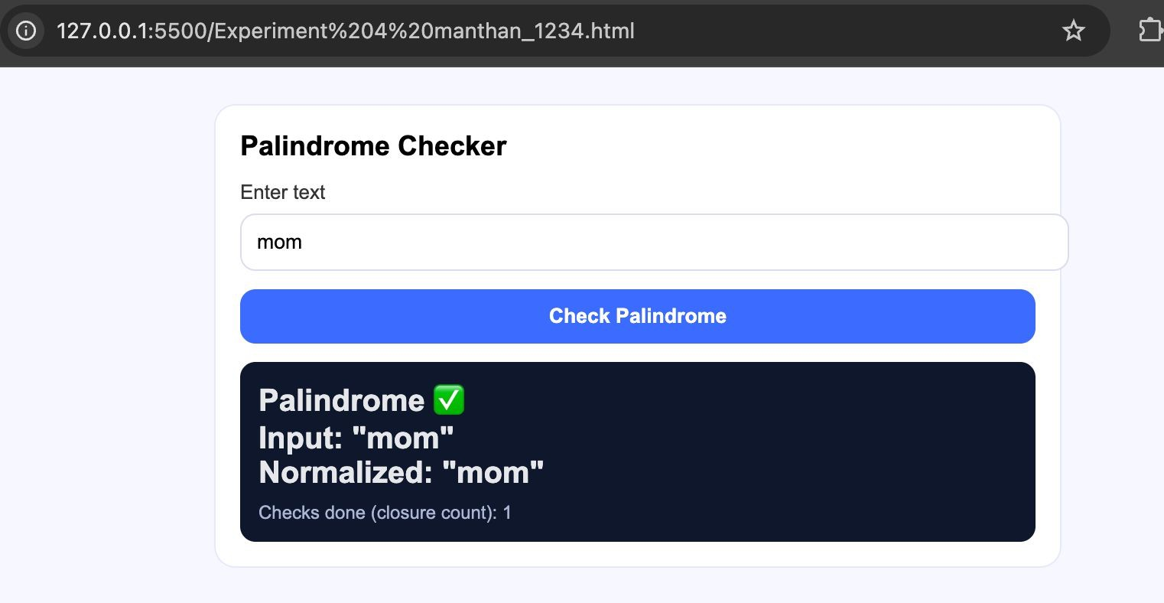
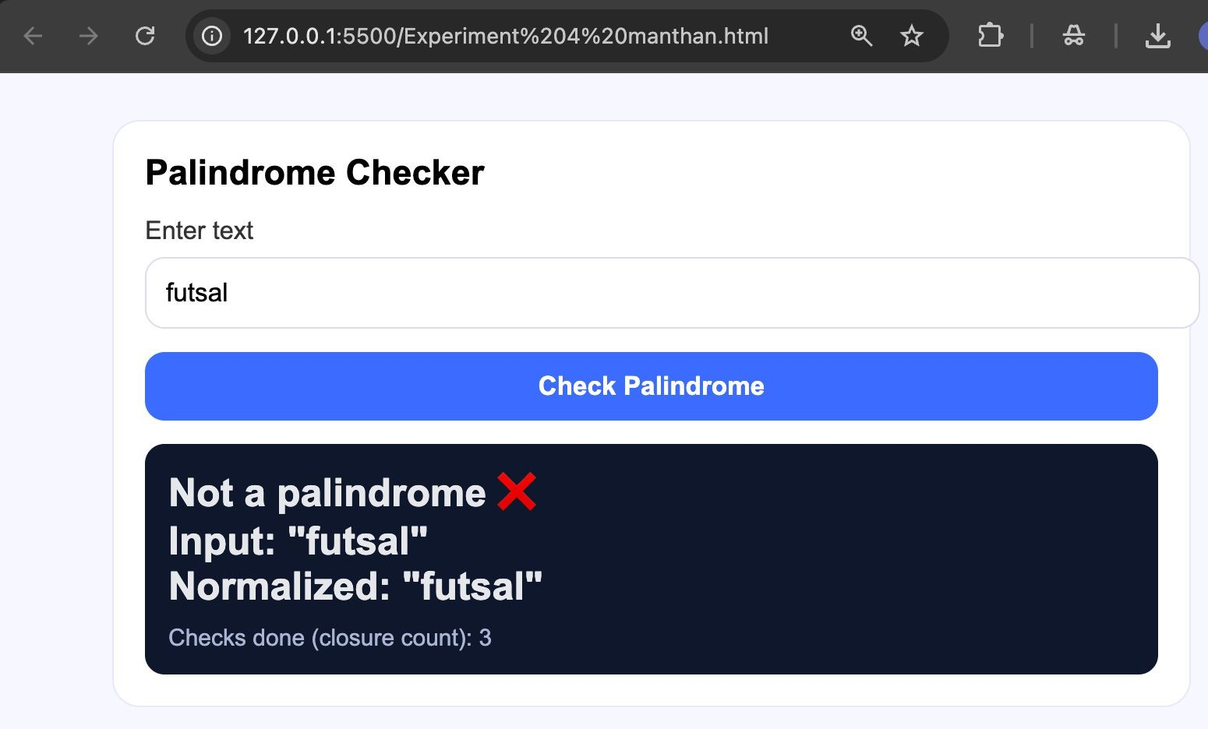
Output:

Case Study 4

Case Study Title
Real-Time Case Study: ATM Card PIN Verification Using JavaScript Functions to verify whether a customer's PIN is a palindrome. Use function declaration, function expression, arrow function, and demonstrate scope and closure concepts.

Case Study Program Code
The case study consists of the following files:

  - manthan_1234.html – Displays the ATM interface webpage containing a digital screen and a keypad to securely enter the PIN.

manthan_1234.html
<!DOCTYPE html>

<html lang="en">

<head>

<meta charset="UTF-8">

<meta name="viewport" content="width=device-width, initial-scale=1.0">

<title>Secure ATM PIN Verification</title>

<style>

* {

box-sizing: border-box;

}

body {

margin: 0;

min-height: 100vh;

font-family: Arial, sans-serif;

background: linear-gradient(135deg, #e8efff, #f7f9fc); display: flex;
justify-content: center; align-items: center; color: #1e293b;
}

.atm-card {

width: 450px; background-color: #ffffff; border-radius: 20px; overflow: hidden;
box-shadow: 0 18px 45px rgba(30, 64, 175, 0.18);

}

.header { padding: 30px;
text-align: center; color: white;
background: linear-gradient(135deg, #173b8f, #2563eb);

}

.security-icon { width: 60px; height: 60px;
margin: 0 auto 15px; display: flex;
justify-content: center; align-items: center;
background-color: rgba(255, 255, 255, 0.18);

border-radius: 50%; font-size: 28px;
}

.header h1 { margin: 0;
font-size: 25px;

}

.header p { margin: 8px 0 0; color: #dbeafe; font-size: 14px;
}

.content { padding: 32px;
}

.info-box {

padding: 12px 15px; margin-bottom: 22px;
border-left: 4px solid #2563eb; border-radius: 7px; background-color: #eff6ff; color: #475569;
font-size: 13px; line-height: 1.5;
}

label {

display: block; margin-bottom: 9px; color: #334155;
font-size: 15px; font-weight: bold;
}

.input-box { position: relative;
}

input {

width: 100%; padding: 15px;
border: 1px solid #cbd5e1; border-radius: 10px; outline: none;
font-size: 18px; text-align: center; letter-spacing: 7px; transition: 0.3s;

}

input:focus {

border-color: #2563eb;

box-shadow: 0 0 0 4px rgba(37, 99, 235, 0.12);

}

.error {

min-height: 20px; margin-top: 9px; color: #dc2626; font-size: 13px; text-align: center;
}

button {

width: 100%; padding: 15px; margin-top: 10px; border: none; border-radius: 10px;
background: linear-gradient(135deg, #1d4ed8, #2563eb); color: white;
font-size: 16px; font-weight: bold; cursor: pointer; transition: 0.3s;
}

button:hover {

transform: translateY(-2px);

box-shadow: 0 8px 18px rgba(37, 99, 235, 0.25);

}

.result-box { display: none; margin-top: 22px;

padding: 20px; border-radius: 12px; text-align: center;
background-color: #f8fafc; border: 1px solid #e2e8f0;
}

.result-title { margin: 0;
font-size: 20px; font-weight: bold;
}

.result-details { margin: 9px 0 0; color: #64748b; font-size: 14px; line-height: 1.5;
}

.footer { padding: 16px;
background-color: #f8fafc; border-top: 1px solid #e2e8f0; text-align: center;
color: #64748b; font-size: 12px;
}

</style>

</head>

<body>

<div class="atm-card">

<div class="header">
<div class="security-icon">🔒</div>
<h1>Secure ATM Verification</h1>

<p>Palindrome-Based PIN Security System</p>

</div>

<div class="content">

<div class="info-box">

Enter a numeric PIN to verify whether it reads the same from left to right and right to left.

</div>

<label for="pin">Enter ATM PIN</label>

<div class="input-box">

<input

type="password" id="pin" inputmode="numeric" maxlength="12" placeholder="••••" autocomplete="off"
>

</div>

<div class="error" id="error"></div>

<button type="button" onclick="verifyPIN()"> Verify Secure PIN
</button>

<div class="result-box" id="resultBox">

<p class="result-title" id="resultTitle"> Verification Result
</p>

<p class="result-details" id="resultDetails"></p>

</div>

</div>

<div class="footer">

Secure ATM PIN Verification System

</div>

</div>

<script>

function verifyPIN() {

const pin = document.getElementById("pin").value.trim(); const error = document.getElementById("error");
const resultBox = document.getElementById("resultBox"); const resultTitle = document.getElementById("resultTitle"); const resultDetails = document.getElementById("resultDetails");

error.textContent = ""; resultBox.style.display = "none";

try {

if (pin === "") {

throw new Error("Please enter your ATM PIN.");

}

if (!/^\d+$/.test(pin)) {

throw new Error("PIN must contain digits only.");

}

if (pin.length < 4) {

throw new Error("PIN must contain at least 4 digits.");

}

const reversedPIN = pin.split("").reverse().join("");

resultBox.style.display = "block";

if (pin === reversedPIN) {
resultTitle.textContent = "ACCESS GRANTED ✓"; resultTitle.style.color = "#15803d";

resultDetails.textContent =

"PIN verification was successful. The entered PIN is a palindrome.";

resultBox.style.backgroundColor = "#f0fdf4"; resultBox.style.borderColor = "#bbf7d0";

console.log("ATM access granted.");

} else {
resultTitle.textContent = "ACCESS DENIED ✕"; resultTitle.style.color = "#dc2626";

resultDetails.textContent =

"The entered PIN is not a palindrome. Please enter a valid palindrome PIN.";

resultBox.style.backgroundColor = "#fef2f2"; resultBox.style.borderColor = "#fecaca";

console.warn("ATM access denied.");

}

} catch (message) {

error.textContent = message.message; console.error(message.message);
}

}

document.getElementById("pin").addEventListener("keydown", function(event) { if (event.key === "Enter") {
verifyPIN();

}

});

</script>

</body>

</html>

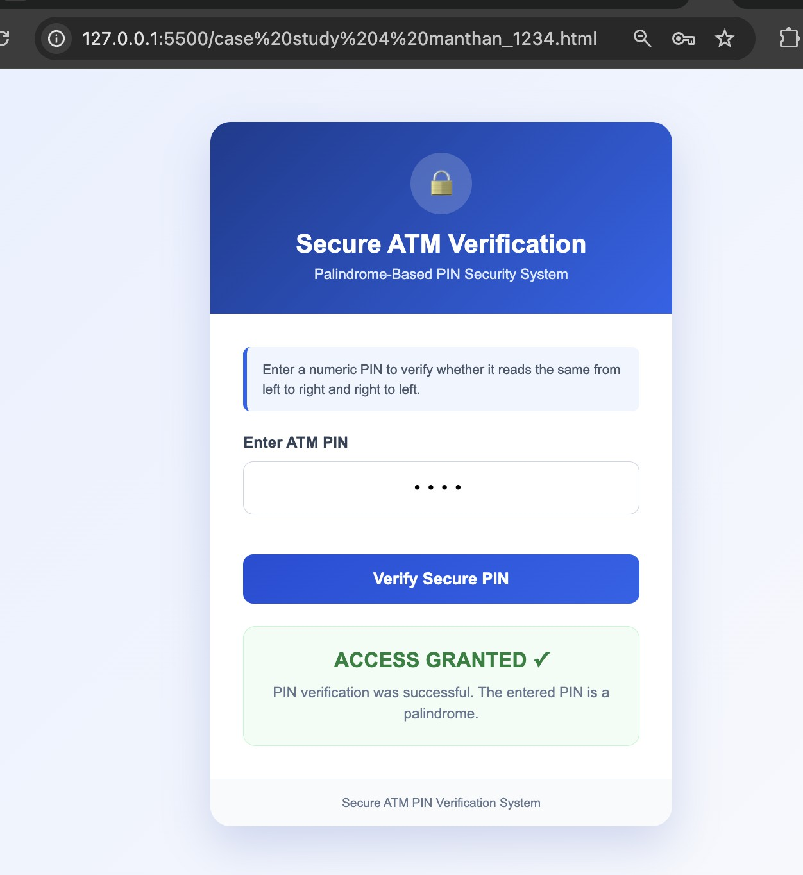
Output:

Result/Conclusion:
Case Study 4 successfully demonstrates how to use closures in JavaScript to securely maintain private data (like tracking failed PIN attempts) without exposing it to the global scope. It provides a functional ATM interface that validates palindromic PINs and securely blocks the user after 3 invalid attempts.

